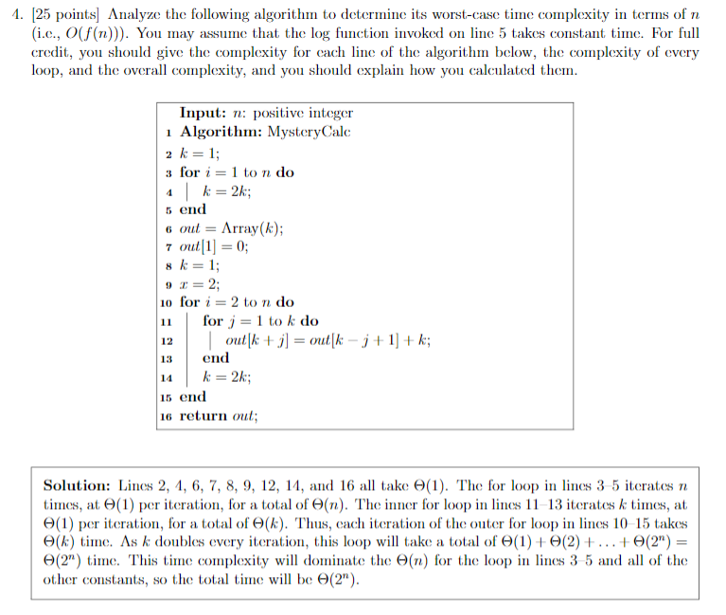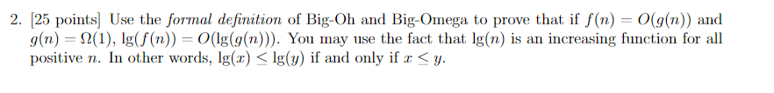

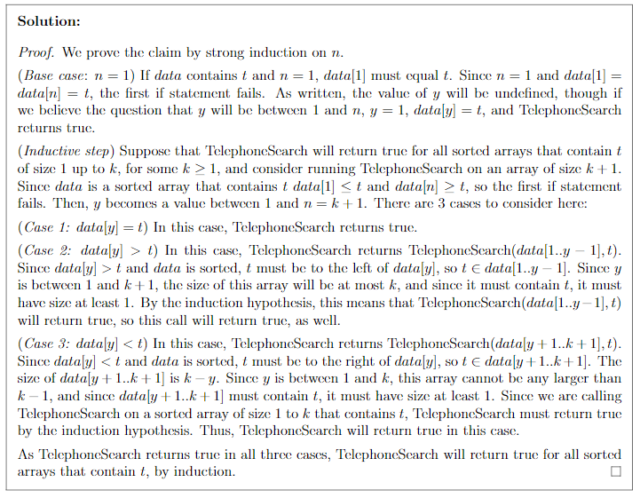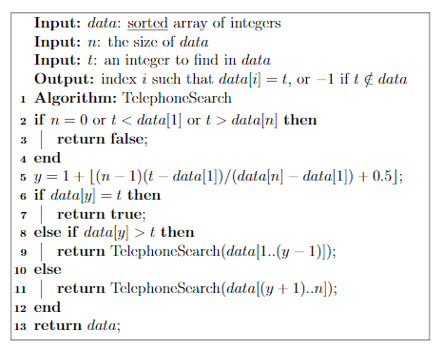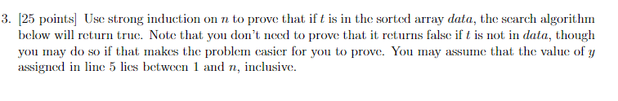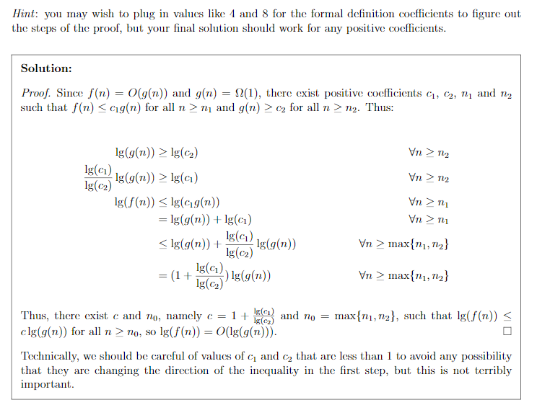

How do we determine correctness?

Correct

For every input, the algorithm must terminate with the Solution

Proof of correctness

1. Start with an arbitrary input

2. Describe what the agorithm does

if statements: proof by cases

for/do/while loops: often need loop invariants

Recursive function calls: induction or strong induction (weak induction -> n-1, otherwise strong induction)

Other function calls: solves associated problem

3. Prove that output meets problem criteria (and terminates)

Sometimes you can use contridiction

Often used for optimization algorithms (max/min, best/worst, etc.)

Suppose algorithm gets the wrong answer and show a contridiction

Incorrect

Find a counter example

